REPORT
NATIONAL SEMINAR ON “IPR: Tool to protect inventions and creations in biotechnology “

Venue: Research Block Date : 9th and 10t January 2020

The Department of Biotechnology organized a two day national seminar on “IPR: Tool to protect inventions and creations in biotechnology “ on 9th and 10th January 2020. The seminar was inaugurated on 9th January 2020 at 10.AM by Dr. C.R.Elsy, Professor (Plant Breeding and Genetica), Convenor - IPR Cell, Kerala Agricultural University, Vellanikkara, Thrissur. Dr. Naijil George, HOD in Charge of the Department welcomed the gathering followed by the presidential address by the principal, Dr.Sr. Isabel. Dr. Sr. Rose Bastin and Sr. Floweret also guided with inspirational words.
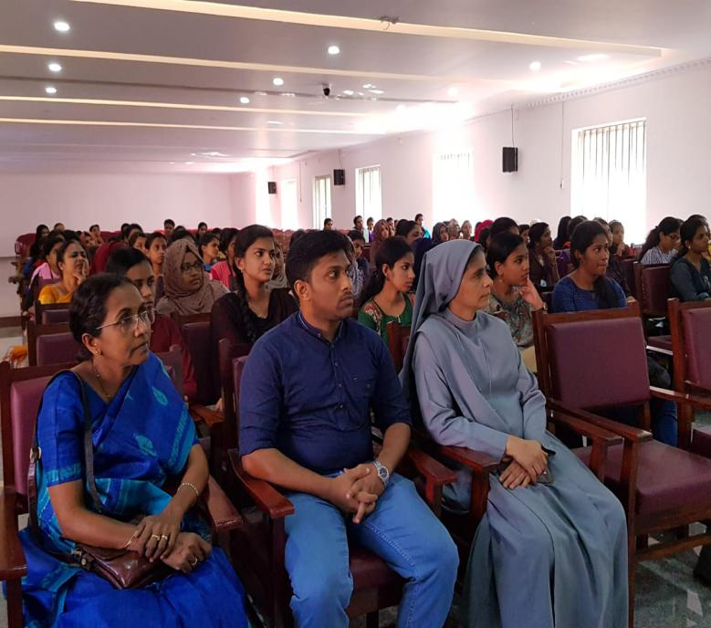
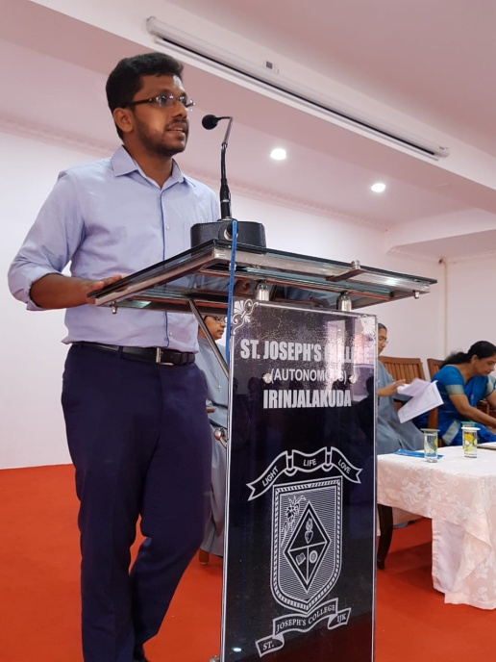
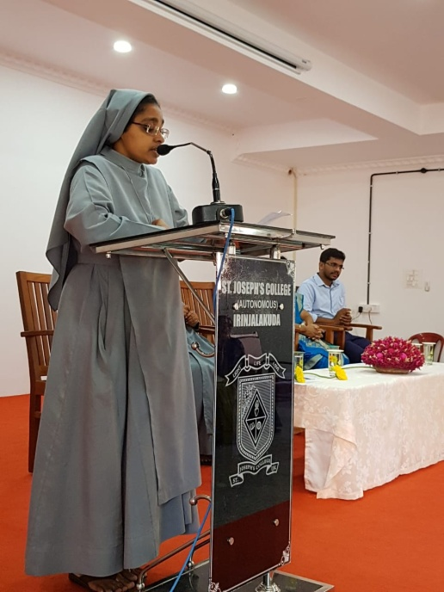
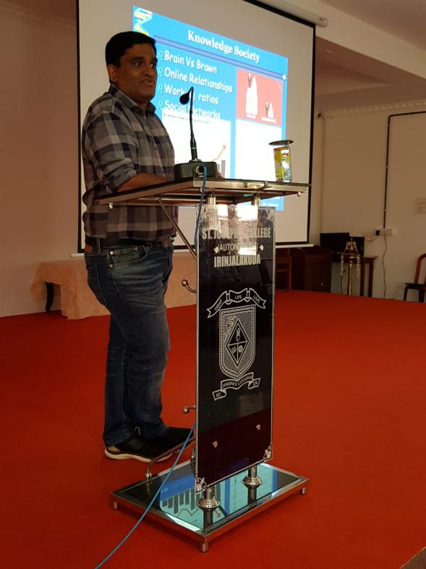
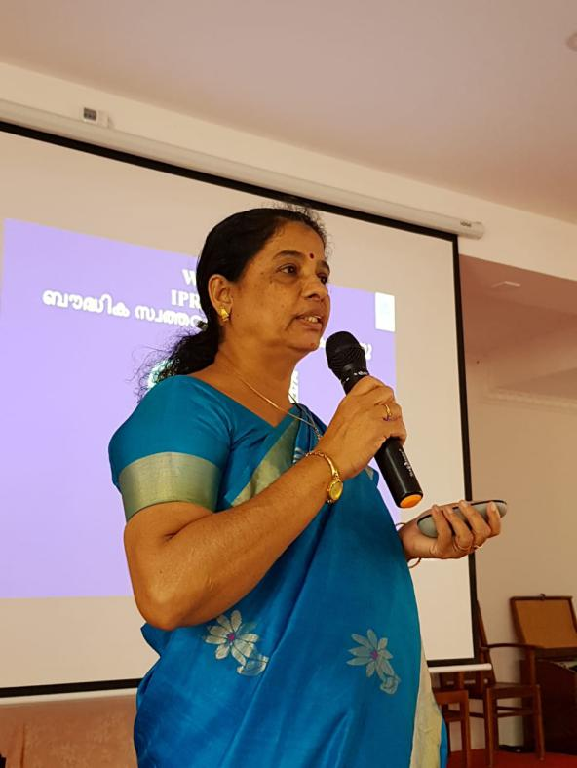
After the tea break, Dr C.R. Elsy gave the keynote address in the topic IPR in biotechnology with special emphasis on ‘Geographical Indication’. She pointed out the need for scientists to go into the field, assess their works and work with communities. She was able to successfully give GI for eight crops in Kerala. Her enthusiasm for work instilled interest in the minds of students.
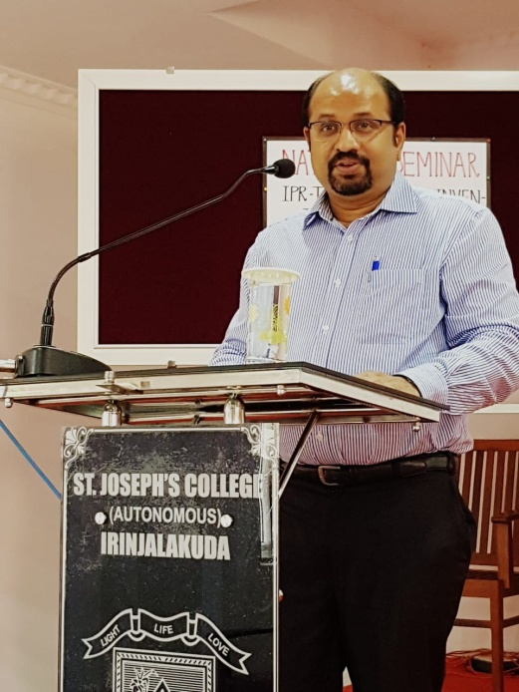
Subsequent session was undertaken by Dr. Leon Ittiachan, professor SCET, Kodakara. He spoke about ‘IPR in Knowledge Economy’ stating the reason behind it and introducing to the golden circle. He also inclined the minds towards thinking about Knowledge revolution and getting to know the history of IPR.
The afternoon session started with the guest speaker Advt. Harikumar C., practicing lawyer, High Court of Kerala, on ‘Infringement’. He was able to give all types of legal advices and covered the basics that a patentee must know.
The morning session on 10th January was handled by Dr. Bhanumathi R., Assistant controller of patent office Chennai. She introduced IPR as career options for students and was able to guide important facts, programs and sessions for future.
The speech was followed by question, discussion and view points of the participants and speakers.
Paper presentation was conducted in the afternoon session where many participated actively. They presented their topic with utmost energy and enthusiasm. The competition was judged by teachers from two different departments to ensure fair judgement.
Certificates were distributed by Dr. Bhanumathi to the winners of Paper presentation. Prizes were also distributed to the winners of PowerPoint presentation and Logo with slogan competition which were conducted at an earlier period of the academic year by the department. It was followed by formal vote of thanks by Association secretary and the event concluded with the National Anthem. It was most heartening to see the overwhelming response of the students throughout the session and dispersed with great incentive that such events take place again.

