International seminar on
‘Interdisciplinary developments in Cancer Research’
Jointly Organized by Department of Computer Science, Department of Biotechnology and Research Centre
REPORT
A two day International seminar on ‘Interdisciplinary developments in Cancer Research’ was organized by the Department of Computer science, Biotechnology, and Research centre of St. Joseph College on 28th and 29th January 2020. Cancer has turned out to be the second most dangerous disease faced by humans in the present world. The most challenging part of it is that as we keep on finding cure to a particular type of cancer, a new type of it arises. Colleges around the city also joined for this auspicious occasion. The seminar focussed on the challenges and issues faced by the researcher in the present scenario. The inaugural programme began with the prayer of almighty. The session started with welcome address by Sr. Blessy, Vice Principal, followed by the presidential address by Rev. Sr.Ranjana, Manager and former Principal of the College. Seminar was inaugurated by Dr. Achuthsankar S Nair, Professor, Department of Computational Biology and Bioinformatics, University of Kerala, by lightening of the lamp followed by the inaugural speech. Felicitations were given by Principal, Dr. Sr. Isabel and Dr. Vrinda V Nair, Deen of Research, APJ Abdul Kalam Technological University, TVM. The vote of thanks was proposed by Dr.P.R.Jayashree, Joint Director, Research Centre.
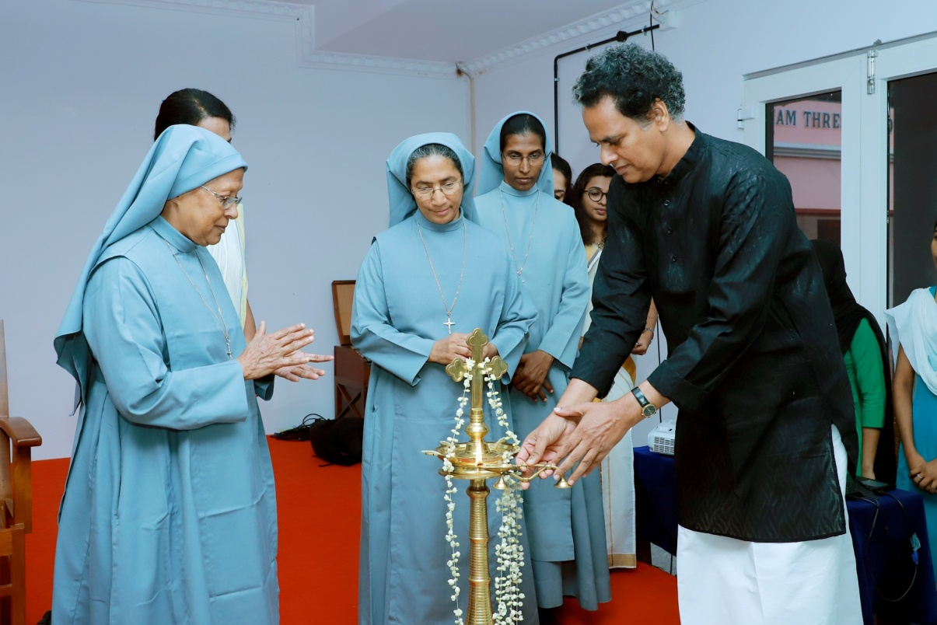

The session by Dr. Achuthsankar began after a short tea break. He outlined the role of Artificial Intelligence, Machine Learning and Deep Learning. He also briefed out certain techniques used in computers.
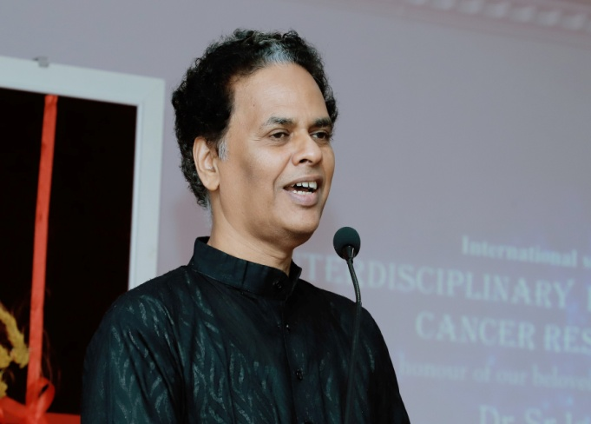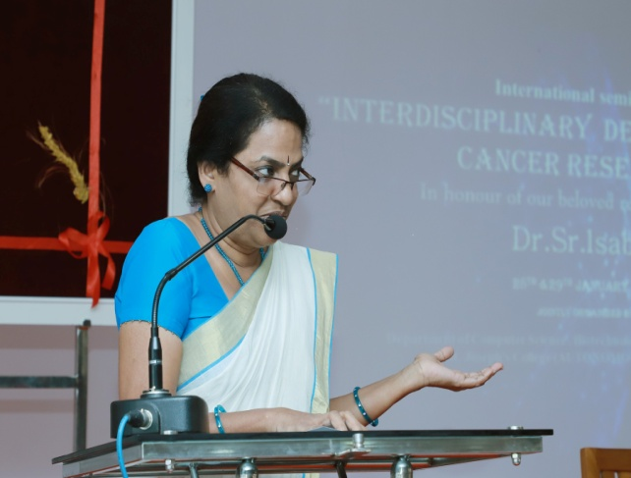
The afternoon session was handled by Dr. Vrinda V Nair. She was able to make the audience understand the importance and relevance of the subject and the role of a good guide in inspiring and motivating the students to aspire his or her goal. The subsequent session was by Dr.Vibha Choudhary, Faculty Scientist, Institute of Bioinformatics and Applied Biotechnology, Electronic city, Bangalore. Her topic was “Tools and techniques used in cancer research”. She was able to explain cancer and its causes and the role of computer technologies in diagnosis of the disease.

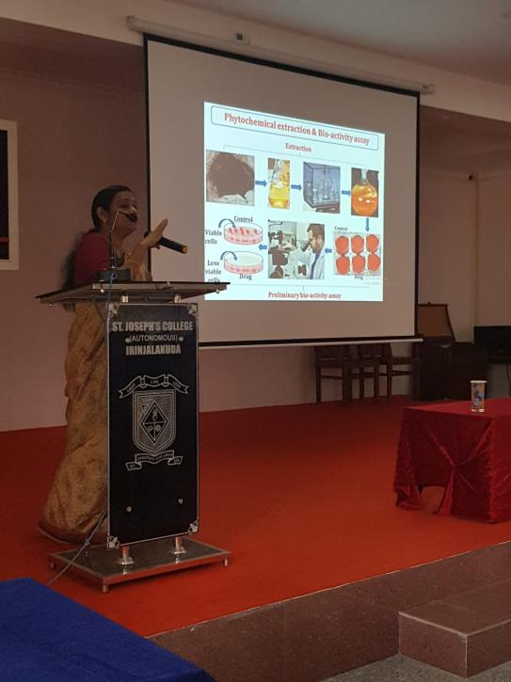
The morning session on 29th January started with a silent prayer followed by the talk of Dr. Ruby John Anto, Scientist G of Rajiv Gandhi Centre of Biotechnology. She spoke on “Evaluation of bioactive principles from natural products as chemo preventives, chemo sensitizers and chemotherapeutics”. It was a wonderful session explaining the research performed by her team. She was able to prove that the plants around us have great wonders and we need to discover those. The session was followed by a short tea break.
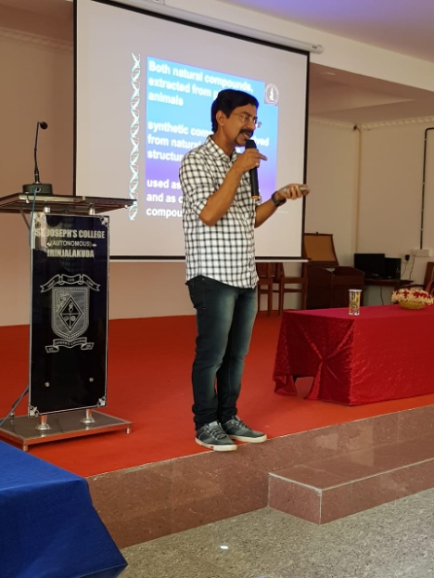
The next session was by Dr. Manish Kumar, formed head and coordinator of University of Calicut. He spoke on “Shifting paradigms in cancer research and therapy”. He was able to go into detail the evolution that is varying from time to time. The paradigm evades crisis through innovation. He was able to influence to think outside the paradigm. He also explained his research and the session was followed by lunch break.
The last session was on “Cre-Lox Transgenic Mice” by Dr. Jayanarayanan S. Texas Tch University Sciences, USA. It was a great session and helped students to understand basics of research using animal models. He introduced to Brief history of Animal Modelling and the transgenic mice.
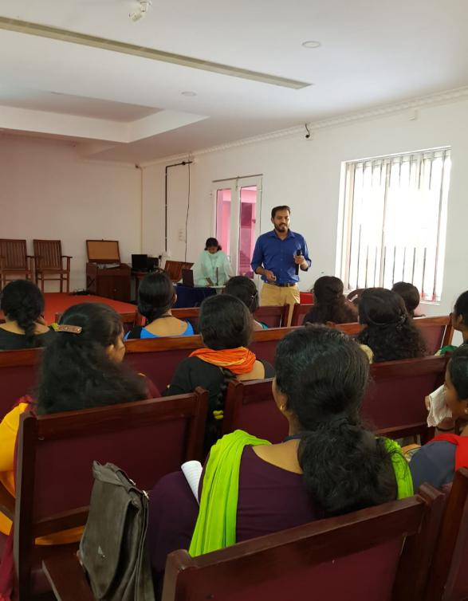
The seminar ended with valedictory session at 3.30 pm. Through the two days sessions, students were enlightened with the novel techniques used in the disease diagnosis and also the current developments in the everyday scientific research happening all over the world.

