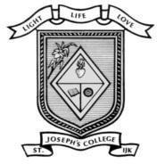
ST. JOSEPH’S COLLEGE (AUTONOMOUS) IRINJALAKUDA
DEPARTMENT OF COMPUTER SCIENCE

Report On Food Fest
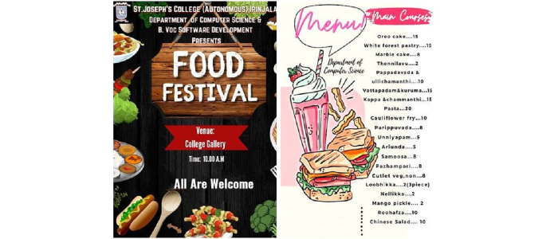
The Department of Computer Science and Bvoc Software Devolopment arranged FOOD FESTIVAL on 21 October 2022 at 10.00 AM To 11 AM in the college Gallery. There are 21 items for the Food Festival.Around 90 Students participated in the this activity.The stalls were arranged and a variety like natural dishes paripouvada pazhampori and English items like pasta, it take initiative by second year bca.All the students and teachers surely impressed taste buds of people.The students got the items,good quality at low cost
The event was beautifully ended for whose who love Both Eating And Cooking.The students Got Good profit and it was the huge success at the end which both students and faculty were happy and satisfied.
