St. Joseph's College (Autonomous).
Irinjalakuda, Thrissur, Kerala, India
College with Potential for Excellence
Re-accredited by NAAC (4th cycle) with A++ grade
Phone no.: +91 8301 000 125

Report on Industrial Visit
Date: 21-Feb-2023
Timings: 08:30 - 11:15 AM
Venue: UST Global , Infopark Campus , Kakkanad
No of Participants:59
Organized For: students of BCA (3rd year) and Bvoc Software Development (1st,2nd year)
Trainer:
Event Co-Ordinators : Ms. Neethu Mohan (Assistant Professor, Bvoc SD), Ms. Geethu Wilson (Assistant Professor, BCA)

A complete report on industrial visit organized by St. Joseph's College (Autonomous).
Irinjalakuda, for the students of Batchelor of Computer Application and Bvoc Software Development in order to get the practical knowledge about “” carried out by UST Global, Infopark Campus - a leading digital transformation solutions company.

Details of journey
St. Joseph's College (Autonomous). Irinjalakuda had organized an industrial visit on 21-Feb-2023 to UST Global, Infopark Campus, Kakkanad for the students of all the 3rd years of BCA and all the 1st and 2nd years of Bvoc SD.

The visit was organized by Hod of Department of Computer Science, Dr. Sr. Siji P D , Ms. Neethu Mohan, Ms. Geethu Wilson were the Faculty Co-coordinators for the industrial visit.
We started travelling from the college campus at 06:30 am via tourist bus. Total
59 students along with Ms. Neethu Mohan, Ms. Geethu Wilson (Event Coordinators) were there in the journey.

Company Profile
UST Global having their own captive campus inside the Infopark. The campus has a self-sustained ecosystem to benefit the working community. UST Global has made a name for itself in the list of top service providers of in India. Has conducted workshops in more than 100 colleges. Conducted more than 150 Industrial Visits to provide a live demonstration of a real network. It is a leading digital transformation solutions company.

Industrial Visit Summary.

This one day, the digital transformation Industrial Visit for students is organized to provide them practical knowledge about UST Global - a leading digital transformation solutions company.
It was an absolute highly motivational Industrial Visit .

Also, it was strictly a non-advertising Industrial Visit. It was held at UST Global , Infopark Campus, Kakkanad where students got an opportunity to acquire a live session about UST Global , about their campus, internships , recruitment process , future scopes so on. And also show the working environment

Benefits of the Industrial Visit to students

1. Students went through in-depth learning of UST Global - a leading digital transformation solutions company.
2. This Iv was held to help students to know about about their campus, internships , recruitment process , future scopes so on .
3. The workshop was delivered using UST Global and Experienced UST Certified Trainers.
4. All the participants were provided with the E participation certificates and
Id cards.

The topics covered were

•Basics of cloud technologies.
•Details must be included in proper resume.
•UST recruitment process.
•UST internships
•Basics of preparation for an interview.
•Need of social media accounts like Linkedin,Naukri,Github so on.
•Advantage of updation of social media accounts.
•Daily updated accounts lead in higher position.
•Need of languages like React,Node JS etc.
•Career growth in the networking field

PHOTO

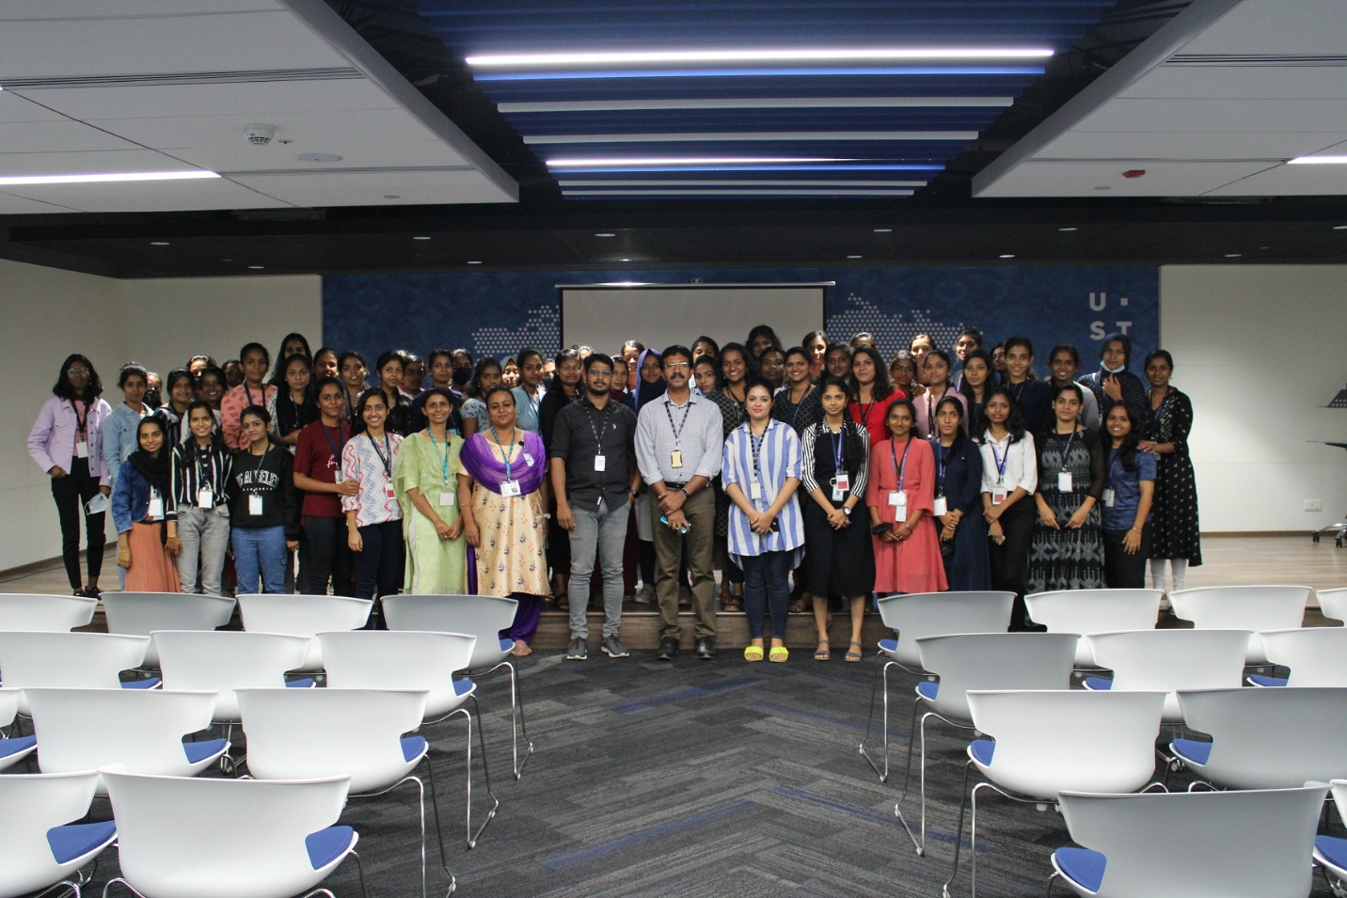

FACULTY ACCOMPANIED
1 | NEETHU MOHAN
2 | GEETHU WILSON

LIST OF STUDENTS ATTENDED:-

SI NO | NAME
1 | ANANNYA M S
2 | SREELAKSHMI K G
3 | ASRITHA AJILPRASAD
4 | DEVIKA SHAJU
5 | FATHIMATHU SUHARA
6 | GOPIKA E S
7 | NAZRIN K A
8 | THASMILA NAZRIN
9 | AISWARYA C.S
10 | ANAIKHA K.A
11 | ANN MARIA JOY
12 | FATHIMA NOUREEN K.M
13 | GHILNA T.B
14 | M.A NAHLA
15 | SAFNA SEBASTIAN
16 | SMERA BISHOY
17 | SREYA SHAMMY
18 | THASNI T.R
19 | THEJA LAKSHMI M.M
20 | AISWARYA RAJAN
21 | ALSAFIYA K B
22 | ANAGHA N.N.
23 | ANJALI KRISHNA T D
24 | ANNA N T
25 | ANSA BENNY
26 | ASWATHY SUDHAKARAN
27 | HRIDYA C.S
28 | JISNA JOY
29 | JISNAMOL SAJI
30 | MEJI A G
31 | SANDRA S MENON
32 | SARITHA SURESH
33 | SHAHANAMOL T N
34 | SHAMOL M S
35 | SREEDEVI K. V.
36 | SREELAKSHMI C SAJAN
37 | SRUTHI SASIDHARAN
38 | ADITHYA SANTHOSH
39 | AMANDA N P
40 | ANEETA K M
41 | ANGEL K J
42 | ANGEL MARIYA
43 | ANJALY K R
44 | ANJANA JOY
45 | ANJANA P J
46 | ANNA WILSON
47 | CHRISTINA JOISON
48 | DEVIKA P R
49 | FARHANA K NAZAR
50 | GAGANA T V
51 | HONEY P S
52 | JEFFY JOHN T
53 | MEGHNA MANIYANKARA DINESAN
54 | NAYANTARA P S
55 | SANDRA JOSHY
56 | SANDRA MARIYA JOHNSON
57 | SANITTA JOHNSON
58 | SREELAKSHMI V B
59 | SWEETY STANLY MS
60 | VISHNUPRIYA VISWANATHAN

