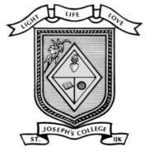
ST. JOSEPH’S COLLEGE (AUTONOMOUS) IRINJALAKUDA
DEPARTMENT OF COMPUTER SCIENCE

CELESTA ZEST 4.O REPORT
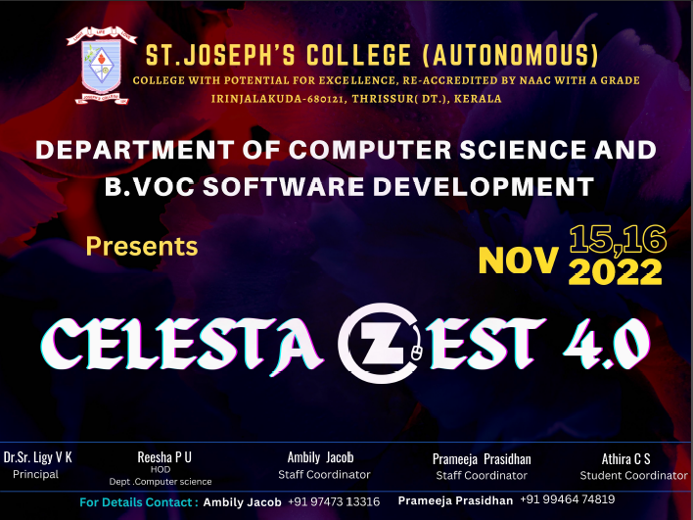
According to the way of life of St. Joseph’s college (autonomous), Irinjalakuda every academic year Department of computer science and b.voc software development organizes inter college technical fest for the aspirants assembling from various colleges with a very highly competitive spirit to participant and with the solid assurance to incorporate their accomplishments and achievements to their resumes. These fests are organized every year with the objective to provide platform for the students to showcase their talent with a competitive spirit. The event was successful enough to attract as many as 100 registrations across the various institutions such as Christ Engineering college Irinjalakuda,Christ college (Autonomous) Irinjalakuda, Sahardaya college of Engineering Kodakkara, St.Thomas college Thrissur, Naipunya College, Prajyoti nikethan college Pudukkad and so on for a two-day inter collegiate fest. As a section our IT Fest we have conveyed fortunate draw coupons all over the place and got many patrons like Grapes Solutions, Galaxy Academy, Victory ITI, Wings Academy Petals, Vellanikaran, Agape Films, Archana Silks for the events. Sponsors for the complimentary prizes are Malabar gold and Diamonds and Bhīma Jewellery Kodungaloor.
We have led Celesta Zest 4. O on 15th and 16th November 2022. But formally we have launched our event 0n 14th November 2022 with a glimmer crowd by flash mob.
Celesta Zest 4. O was inaugurated by our dear principal Dr.Sr. Elaiza, vice-principals Dr.Sr. Floweret, Dr.Sr. Blessy,self-financing programme coordinator Dr.Sr.Rosebastin, Retirees Dr.Asha Head, Research Department of English, Ms.Reesha P.U ,Head-in charge department of computer science, Staff coordinators Ms.Ambily Jacob,Ms.Prameeja Prasidhan,Student coordinator Athira shivadas,Association SecretaryMeghna Maniankara Dineshan by blowing balloons. We had all out of 11 events recorded as: Coding, Quiz, Idea Pitching, Click and Talk, Photography, Presentation, Treasure Hunt, Troll making, Face Painting, Spot Games, Spot Dance.We had likewise organized Virtual Reality Show by ManasVR Lab pvt Ltd Thrissur and Food stall by the students in our department. On 16th November 2022 at 2:30 Pm we are leading validatory function at Research seminar hall. Prize conveyances of different events and Fortunate draw victors will be given by our Chief Guest of the event Dr.Sr. Rosebastin (self-financing programme coordinator). With the valedictory function on second day afternoon, the program reached a conclusion.

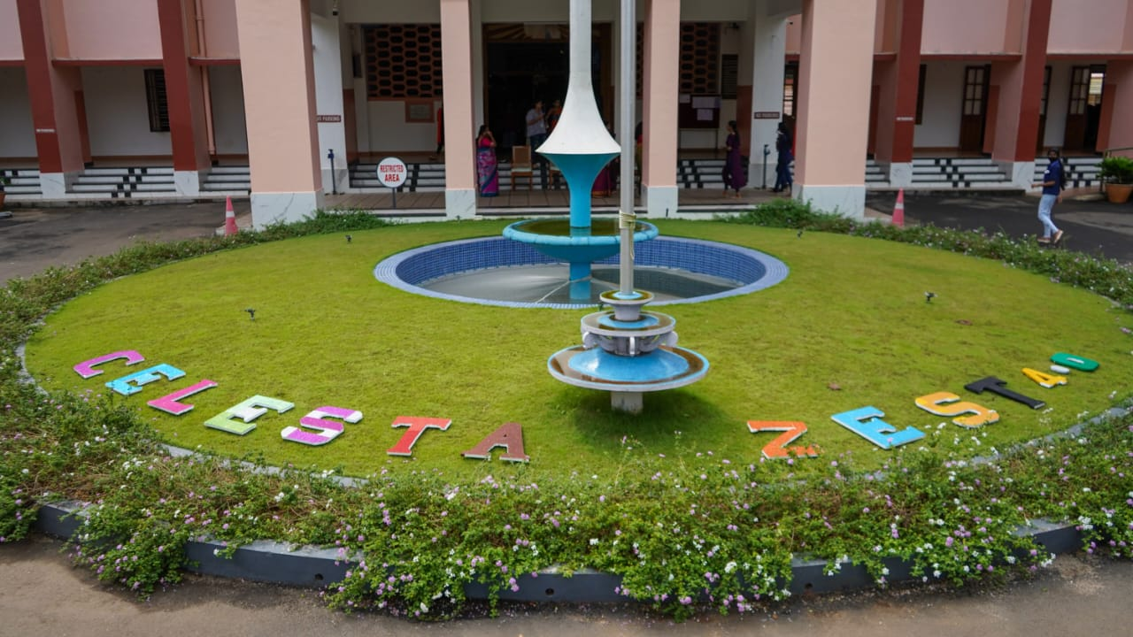

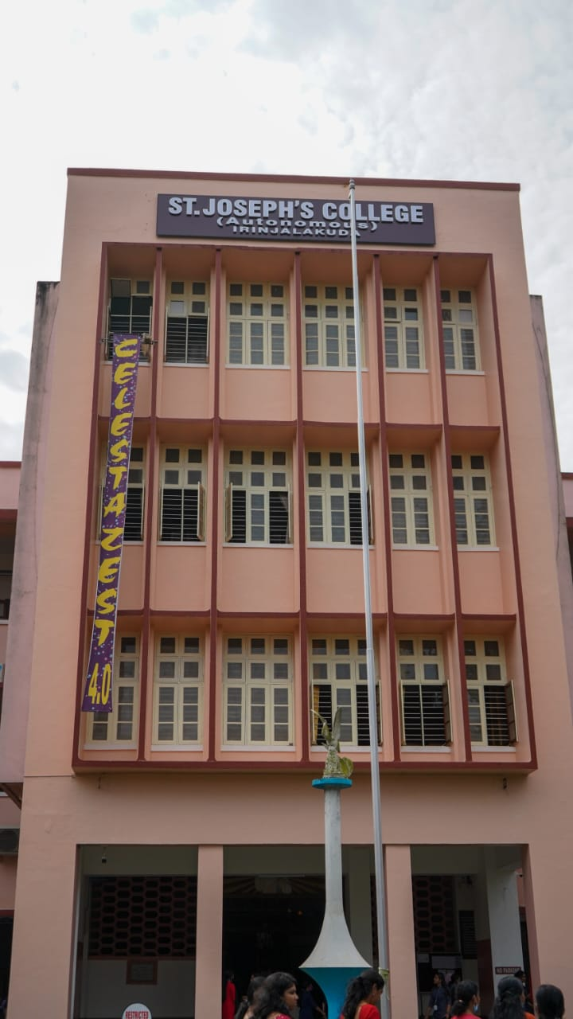
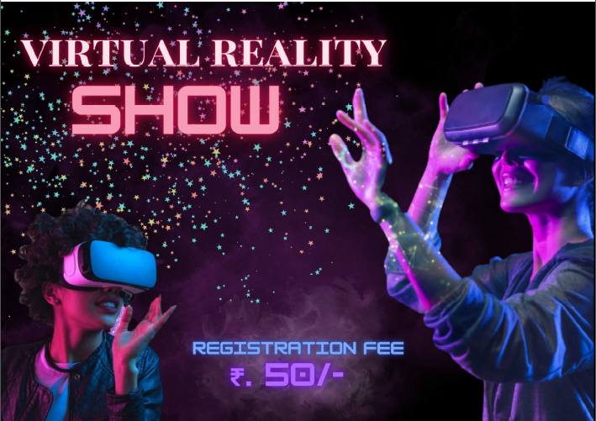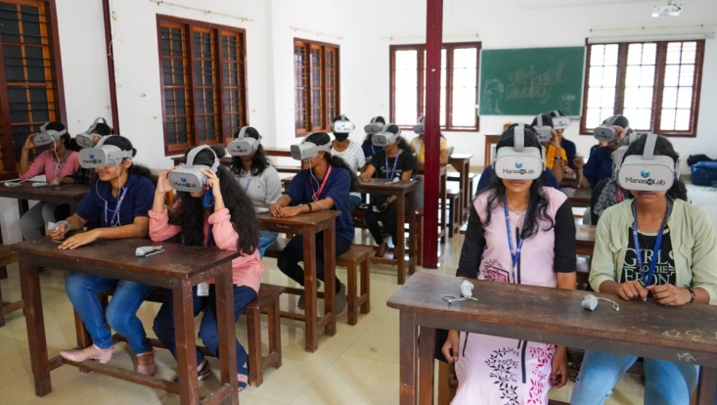
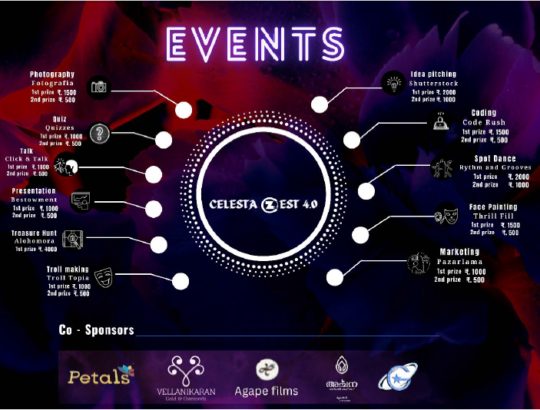

Competition Result

Photography competition
First prize : Abirudh suresh (Christ college)
Second prize : Simon B (Christ college)

Click and Talk
First prize : Rohit Raj (Naipunaya institute )
Second prize : Henna Rose Johnson(St.Joseph College)

CodeRush
First prize : Aneena Joseph Akkara (Christ college)
Second prize : Mohammed Ansal P.A(St.Thomas College)

Quiz
First prize : K.Mervin Dennis , Viswanand A.S(Christ college)
Second prize: Sabi Baiju ,Fathima Nasimi (St.Joseph college)

Marketing
First prize : Aswathy (St.Joseph college)
Second prize : Anamika Jestin (St.Joseph college)
Treasure Hunt
First prize : Nimal K.N , Akhilash Muraleedhran , Blessen George,
Naveen Nihal , Hashim(Christ college)

Idea Pitching
First prize : Aswathi, Sabi Baiju(St.Joseph college)
Second prize : Merin ,Sravana , Anamika jestin (St.Joseph college)

Spot Dance
First prize : Aneeta Babu , Lakshmi Nanda (St.Joseph college)
Second prize : Hecksy.S.Parayil , Devika C Dileep(St.Joseph college)

Face Painting
First prize : Aswathy K J , Malavika Prakash (St.Joseph college)
Second prize : Louna P M , Gladdy pereira (St.Joseph college)

Troll Making
First prize :Deon E D (prajyothinikethan college)

