
College with Potential for Excellence
ST.JOSEPH’S COLLEGE (AUTONOMOUS)
IRINJALAKUDA, THRISSUR, KERALA, 680121
DEPARTMENT OF SOCIAL WORK
Email: socialwork@stjosephs.edu.in

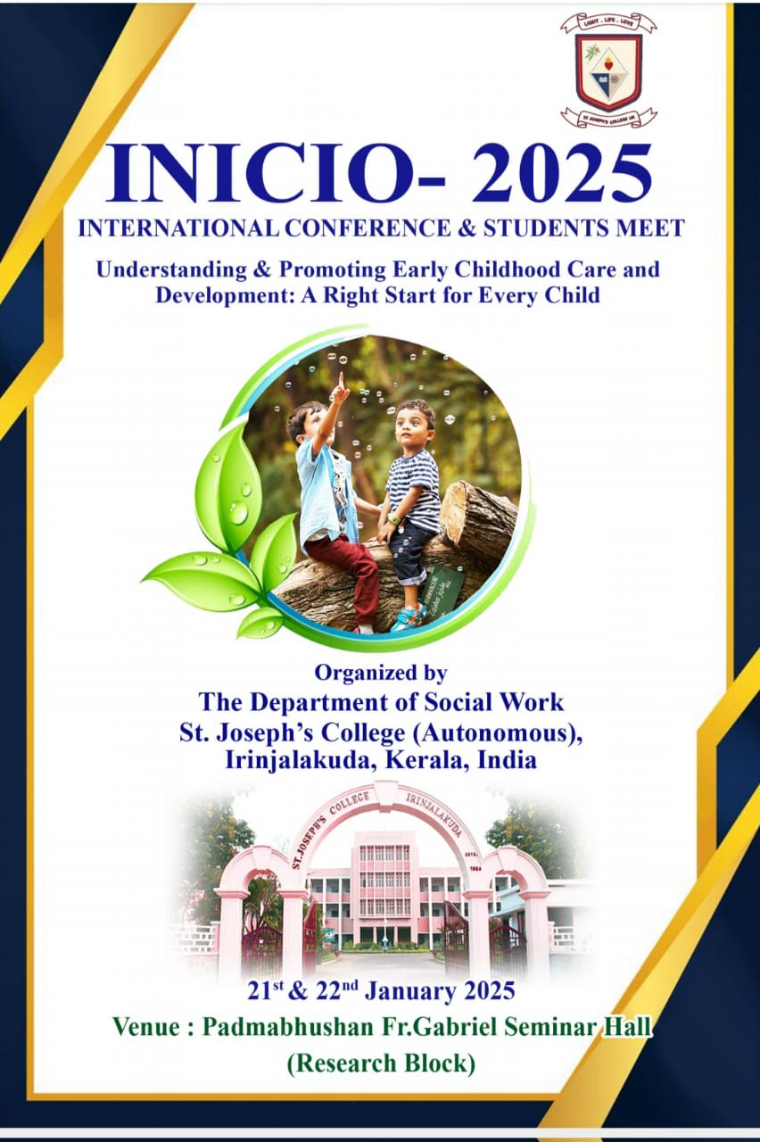

REPORT

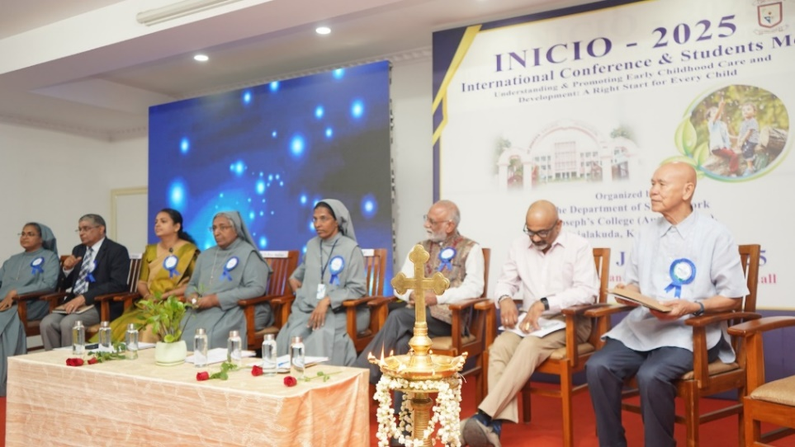
The Department of Social Work at St. Joseph’s College (Autonomous), Irinjalakuda, organized INICIO-2025, the International Conference on “Understanding and Promoting Early Childhood Care and Development: A Right Start for Every Child,” on January 21, 2025, at the Padmabhushan Fr. Gabriel Seminar Hall. The event began at 9:35 AM, focusing on the critical importance of early childhood development.
Sr. Dr. Jessy K.C., Head of the Department of Social Work, extended a warm welcome, emphasizing the significance of early childhood care and the shared responsibility of society in nurturing children, and welcomed the distinguished guests and dignitaries, whose expertise enriched the conference.
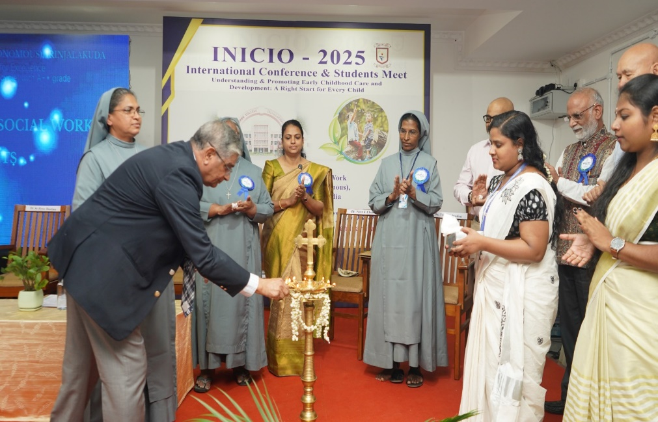
Mr. Gopinath T Menon, retired Chief of UNICEF Maharashtra State Office, provided an overview of the conference during the introduction. He highlighted the critical need for proactive measures such as awareness programs and education to combat this challenge, underlining their role in improving child development and fostering a healthier future generation.
In the presidential address, Dr.Sr. Siji P.D. recognized early childhood as a pivotal phase for health, learning, and overall well-being, encouraging innovative solutions to ensure holistic child development.
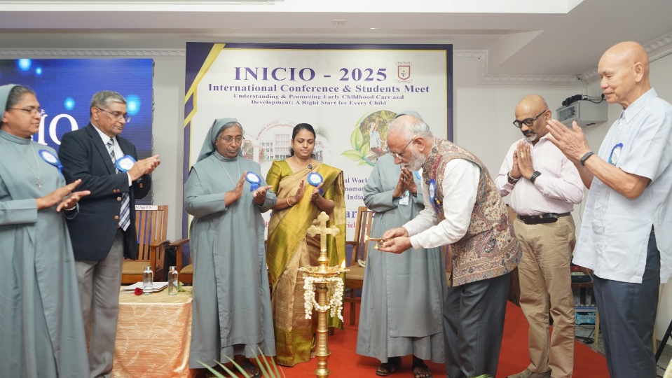
Dr. Sanjiv Kumar Former Regional Advisor, UNICEF Central Asia, Central, Eastern Europe and Baltic States, Former Director, National Health Systems Resource Centre (GOI) highlighted India's significant improvement in life expectancy and underscored the transformative role of empowered caregiving in shaping a child's future. He emphasized the importance of foundational elements such as health, nutrition, safety, and early learning as essential pillars for ensuring holistic development and well-being.
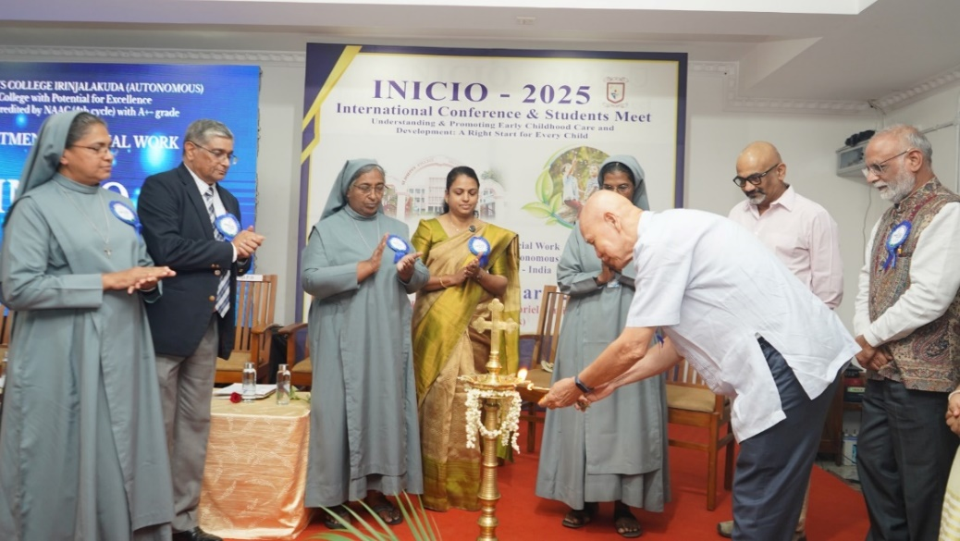
Dr. M.K.C. Nair, in his keynote address, advocated for a life-cycle approach to child development, stressing the importance of early habilitation to prevent disabilities. He also discussed effective interventions for developmental delays and highlighted the Trivandrum district model as an exemplary framework for managing childhood disabilities.
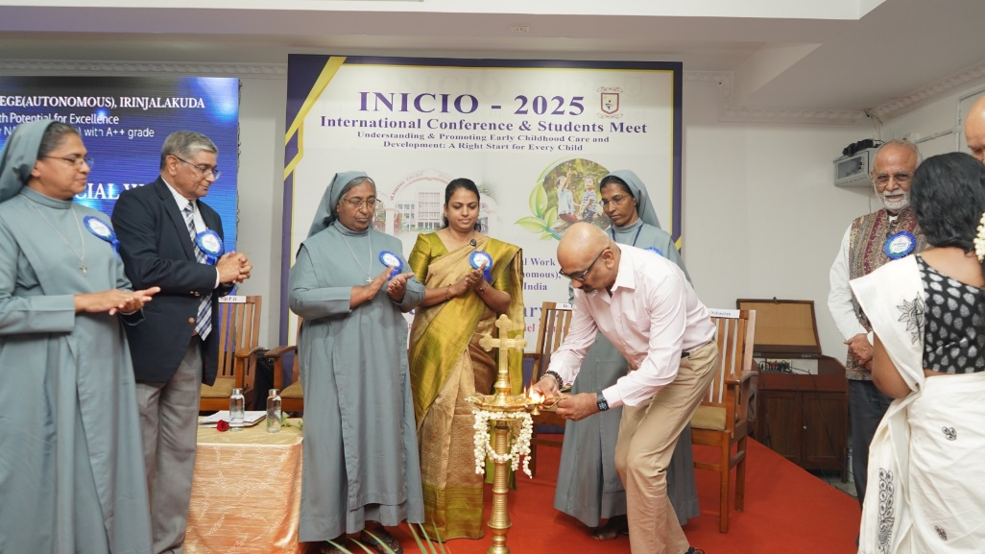
During the felicitations, Dr. Sr. Rose Bastian, Self-Financing Program Coordinator, highlighted the societal changes brought about by migration and their impact on caregiving, urging a collective responsibility to nurture children. Dr. Binu T.V., IQAC Coordinator, expressed pride in the institution’s dedication to excellence and its proactive role in community engagement. Ms. Saji Nellisserry, Counselor at Scarborough Women’s Centre,Toronto, Canada emphasized the complexity of childhood issues and underscored the importance of adopting a collaborative approach to address them effectively.
The inaugural function of the conference concluded with a heartfelt vote of thanks delivered by Ms. Mary Amrutha K.C., Assistant Professor, Department of Social Work.
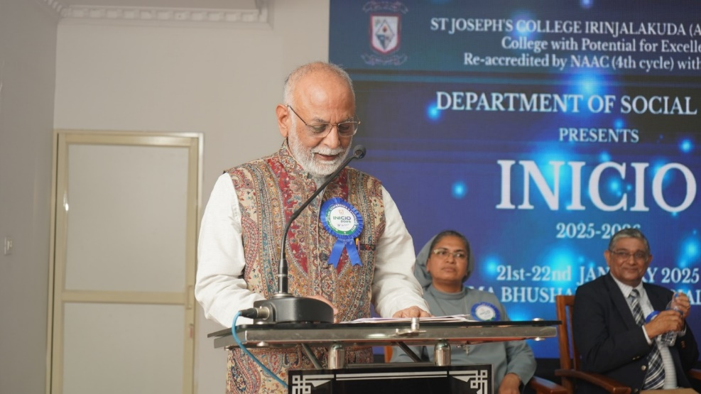
The technical session, conducted by Dr. Sanjiv Kumar, former UNICEF Regional Advisor and an expert in health leadership, focused on the critical importance of early childhood development, The second session, led by Dr. Sethu Warrior, Senior Consultant at the National Health Services, UK, focused on debunking the misinformation surrounding "virtual autism," a misleading term often used to downplay genetic factors in autism. He stressed that "virtual autism" is not recognized in ICD or DSM, advising social workers to avoid using the term in diagnoses. The third technical session focused on “Studies in Child Development: Scope and Potential” and was presented by Dr. Thara Sebastian, Retired Associate Professor and Head of the Department of Home Science at St. Teresa’s College, Ernakulam.
The fourth session, conducted by Dr. Peter F. Chen, Former Deputy Regional Director and Regional Advisor, UNFPA South East Asia Region, focused on “Social and Behavioural Change (SBC) Communication for Early Childhood Care and Development.”
The fifth session was presented by Mr. C. Chandrababu, Executive Director of the National Institute of Physical Medicine and Rehabilitation (NIPMR), Kallettumkara. He introduced NIPMR's governing bodies, key departments, and services, including group therapy, home visits, parental support, and counseling.
The second day began with the welcome and introduction of our students…
Nearly 200 participants attended the conference including students, academicians, and practitioners from various institutions. There were 17 papers presented on the theme of early childhood care and development. A panel consisting of Dr. John Menchery, Former Dean of Tata Institute of Social Sciences as well as former principal of the Institute of Social Work at Nagpur University, Dr. Sheelamma, Assistant Professor, Department of Social Work, Sreesankarajarya University of Kalady, and Dr. Gigi Poulose, Former HOD and Assistant Professor of the Department of Zoology, St. Joseph’s College, Irinjalakuda assed the presentations. Various events consisting of poster-making competitions, Face painting Competitions, and Treasure hunts based on the theme were held today as part of the INICIO 2025. The winners of the competitions are being awarded during this Valedictory.
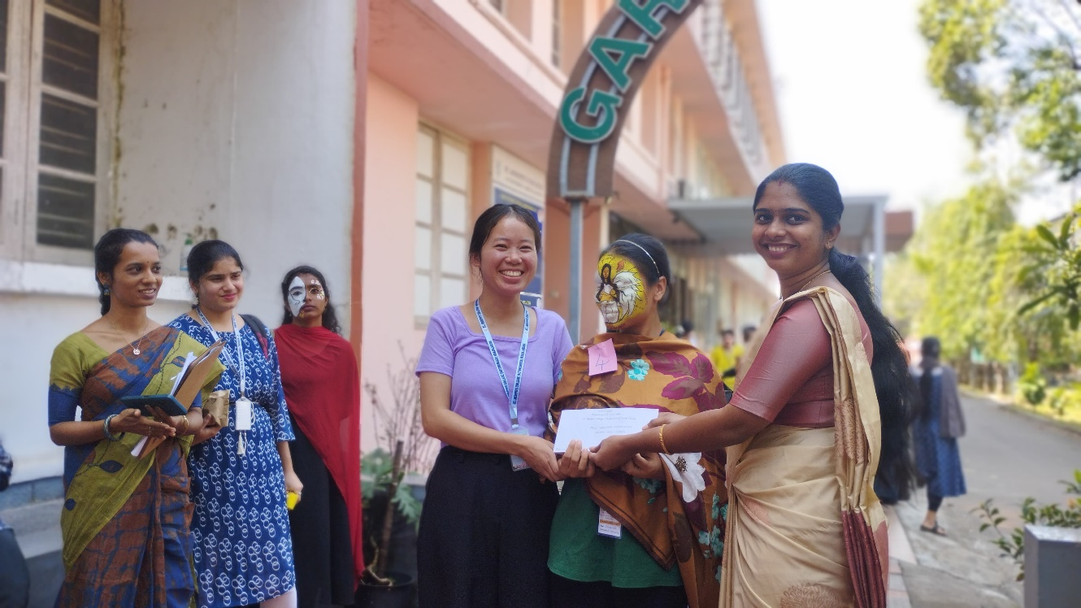
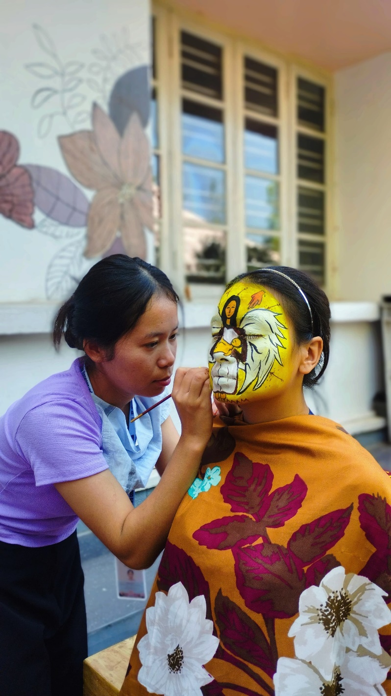
Valedictory Function Report
The INICIO 2025 International Conference on “Understanding and Promoting Early Childhood Care and Development: A Right Start for Every Child” culminated in a memorable Valedictory Function on January 22, 2025.
The event commenced with an invocation by Dharsana Lal/Smrithy, followed by a welcome address by Krishnendhu K. B. Dr. Jessy K. C. presented a comprehensive report on the conference proceedings, highlighting the key takeaways and outcomes.
The valedictory address, delivered by John Menachery, a Former Professor and Dean at the Tata Institute of Social Sciences, who shared his expertise and insights on promoting early childhood development.
Conference certificates were distributed to the participants, followed by concluding remarks from Dr. Sr. Anjana, Vice Principal of the college. Ms. Sruthy Deepak proposed the vote of thanks, expressing gratitude to all the dignitaries, speakers, and participants.

The Valedictory Function marked the successful conclusion of the INICIO 2025 International Conference, which provided a meaningful platform for experts and stakeholders to share knowledge, experiences, and best practices in promoting early childhood care and development

Key Outcome of the Conference
- The conference has provided valuable insights into the critical importance of early childhood care and development in shaping a child's future.
- A significant outcome of the conference is the decision to launch a signature course on this theme under the Department of Social Work which seeks to reinforce the department's commitment to fostering a sustainable and inclusive future for every child.
- The conference wishes to create a core of trained professionals who can champion the cause of early childhood development and contribute meaningfully to policy and practice in this vital field.
The insights and resolutions from this conference reaffirm our collective responsibility to advocate for equitable, inclusive, and sustainable approaches in early childhood development, paving the way for a brighter future for all children worldwide.
Photo Gallery

